John Ruskin: Prophet of the Anthropocene Notre Dame University, Indiana
8 February 2020

Ruskin’s Guild of St George,
Yesterday and To-Day

Ruskin Birthday Lecture
by Clive Wilmer
Emeritus Fellow of Sidney Sussex College, University of Cambridge;
Master of the Guild of St George, 2009-19

In 1869, Ruskin was appointed the first Slade Professor of Fine Art at the University of Oxford. It was a quite exceptional honour and he was deeply gratified. As he immediately pointed out in a letter to his Mother, ‘I am the first professor of art appointed at the English Universities.’ What is more, as he says in the same letter, the new role would give him ‘as much power as I can well use’. Ruskin was not immune to the pleasure of being honoured, but usefulness – the ability and opportunity to communicate what he believed in – was the thing he most sought and was inclined to feel he lacked. He was indeed to be delighted by the huge audiences that attended his Oxford lectures but equally disappointed by the failure of his words to make much impact on the wider world. Ruskin was prone to depression and inclined to feel neglected; he also looked for a greater impact than it was possible for one person to achieve. Nearly a decade later, he was to attribute his first mental breakdown, not (as his doctors had said) to overwork, but to his sense that ‘nothing came of my work’ (29.386). Though he was also given to exaggeration, he was surely right to complain. Even today, though we can now see how right he was about so many things, he is not much heeded and rarely acknowledged. We talk a great deal these days about the need for ‘outreach’ and ‘impact’ in cultural and educational matters. Though Ruskin would have deplored the utilitarian foundations of these requirements as they are usually prescribed today, he deeply believed in the organic relationship between culture and society. Oxford was the place where Britain’s future leaders were educated. If he could make his audiences listen, he would influence the future generations, which is what he wanted more than anything to do.
Nevertheless, grateful as Ruskin was for this new appointment, it did put him in something of a quandary. As he conceded in another letter to his mother, he already had ‘too many irons in the fire’ and taking on the Slade Professorship, which in his understanding of it involved more than simply lecturing, more than doubled his workload, already heavy enough. Moreover, though since as early as 1844 he had been arguing for the recognition of art as an academic discipline, he had in his own work moved away from pure art criticism to a kind of social criticism in which art played a vital but secondary role. It has been often noted that, early in 1860, having handed the final volume of Modern Painters to his publisher, he almost immediately began writing his ‘Essays on the First Principles of Political Economy’, published two years later as Unto this Last. He had persisted in this new direction with Munera Pulveris (1864) and Time and Tide (1866) and, in his many lectures of the period, the criticism of art is mingled with – even invaded by – social criticism. The truth is that Ruskin was not sure how useful his art work could be in a society whose chief value was competition. How could beauty arise from a populace that was denied access to the primal source of beauty, a natural world untainted by waste and pollution? If art, as he had long argued, reflected its society, modern society could only produce an art that was diseased.
Moreover, in his teaching at Oxford he would be bringing knowledge and wisdom only to the sons of the ruling class. He had no objection to that, believing as he did in a hierarchical society with different classes fulfilling different roles, but he was also concerned at how little in the way of knowledge, wisdom and appreciation of beauty was imparted to working people. ‘Perhaps, having now committed himself to Oxford,’ writes his biographer Tim Hilton, ‘Ruskin felt that he should also speak to unlettered men.’ So he now needed a way of addressing such men, and possibly women too, and it had to be through something he could write (as it were) alongside his Oxford lectures. It was probably for this reason that, in January 1871, having given the first and second series of his Slade lectures, he embarked on the strange work called Fors Clavigera, a monthly series of – to quote the subtitle – Letters to the Workmen and Labourers of England. In precisely what sense they were addressed to working people has never been clear. Recondite, allusive and technically innovative as they mostly are, they might have been conceived for the most sophisticatedly literary of audiences, the Latin title alone requiring several pages of text for explanation and still remaining to some degree obscure. Nevertheless, where the Slade Lectures deal mainly with matters of art and art history, Fors is clearly a means of attending to the issues of the moment, month by month. Furthermore, though I think the phrase ‘workmen and labourers’ was meant to apply to people of that description as generally understood, it seems likely that Ruskin was also thinking of all those who work – ‘brain-workers’ like himself as well as farm labourers and industrial operatives.
In January 1871, in the first letter of Fors, Ruskin announced another project intended for workers of all classes. This was St George’s Fund, the kernel of what was to have been St George’s Company but, seven years later, became the Guild of St George. Ruskin had been thinking of his company not as a business designed to make profit – which is how Companies House understood the word – but as a Company of Knights: the St George he had in mind was the knightly saint of medieval iconography. The word ‘Guild’, which also had medieval associations, was less obviously appropriate, characterising a society for the mutual support of people working in a common trade or craft. Though the word had already been revived in the 1870s, it was perhaps as a result of its use by Ruskin that it became popular with his admirers in the Arts and Crafts movement, who organised themselves into co-operative bodies such as the Century Guild of Artists (1882), the Art Workers’ Guild (1884) and the Guild of Handicraft (1888). We do not know how or when the idea of founding a Guild first struck Ruskin – it seems almost to have sprung out of nowhere – but it is possible to trace a number of sources. One must have been his visit in the summer of 1869 – the summer in which he was offered his Professorship – to the Scuola di San Giorgio degli Schiavoni in Venice.
Ruskin had long been attracted by the Venetian scuole. These were charitable bodies rooted in particular districts of Venice, supportive of the poor or disadvantaged in those districts, concerned with social cohesion, and generous in their patronage of the arts. Ruskin’s interest had centred mainly on the Scuola Grande di San Rocco with its magnificent collection of sixty-one paintings by Jacopo Tintoretto (1519-94), the sixteenth-century artist he admired above all others. On the occasion in question, however, he had been directed to a scuola as yet unknown to him by his friend, the painter Edward Burne-Jones. Burne-Jones had been excited by his discovery of an earlier artist, Vittore Carpaccio (c. 1460/5 – 1523/6), who was like Tintoretto in associating himself with the scuole, but otherwise very different – still, in the period 1502-07 when he worked in the Scuola di San Giorgio, rather Gothic in feeling. Taking up his friend’s recommendation, Ruskin was bowled over by the nine Carpaccio canvases that confront the visitor on entering the building, especially the first, St George Slaying the Dragon.

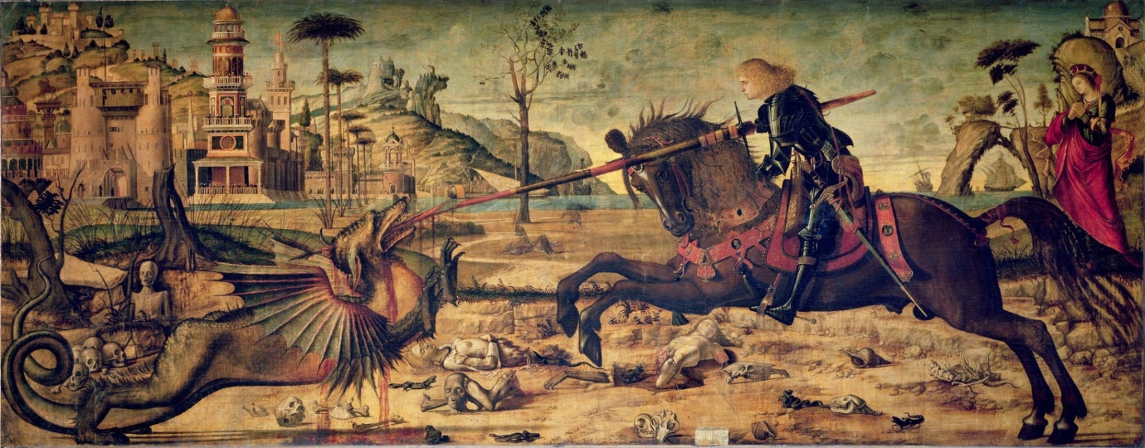

Vittore Carpaccio (1465-1520), St George slaying the Dragon (1502)
Oil on canvas. Scuola di S. Giorgio degli Schiavoni, Venice

Ruskin’s imagination must have been stirred by a possible comparison of Carpaccio’s picture with a detail he had reflected on a decade before in J.M.W. Turner’s painting The Goddess of Discord Choosing the Apple of Contention in the Garden of the Hesperides (1806), the title of which refers to the origins of the Trojan War: perhaps meant to be understood – at the time of the Napoleonic War, when Turner painted it – as a paradigm of all human conflict. The detail in question is the dragon which guards the golden apples of Hera, Queen of the Gods – Juno in the Roman pantheon – at the western entrance to the Mediterranean. Ruskin singled out that detail in one of the plates to Modern Painters V (1860), giving it the characteristically cryptic title, ‘Quivi trovammo’.

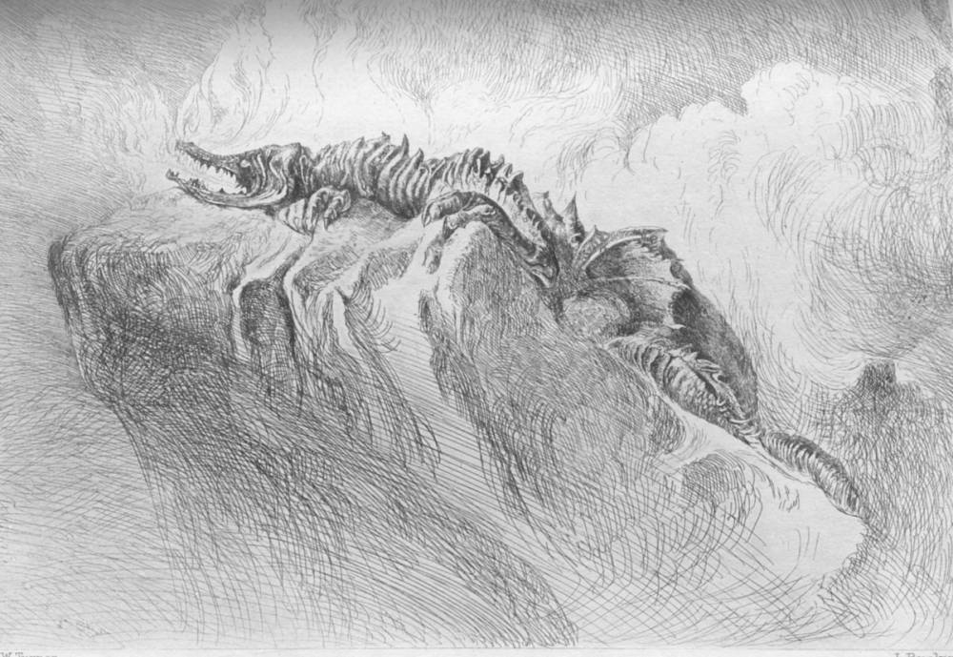

John Ruskin, Quivi trovammo.
Engraving after J.M.W. Turner (Plate 78: 7.402)
A quotation from Dante’s Inferno, this title tells us to imagine ourselves in Hell. Here is the context:

venimmo al punto dove si digrada;
quivi trovammo Pluto, il gran’ nemico.

(‘we reached the point where the descent begins;
here we found Plutus, the great enemy.’)

In Turner’s picture, the dragon is only just visible. At first sight, he looks like a rugged ridge at the top of a distant crag, but in terms of both subject and composition he is at the core of the painting. We have to look for him and

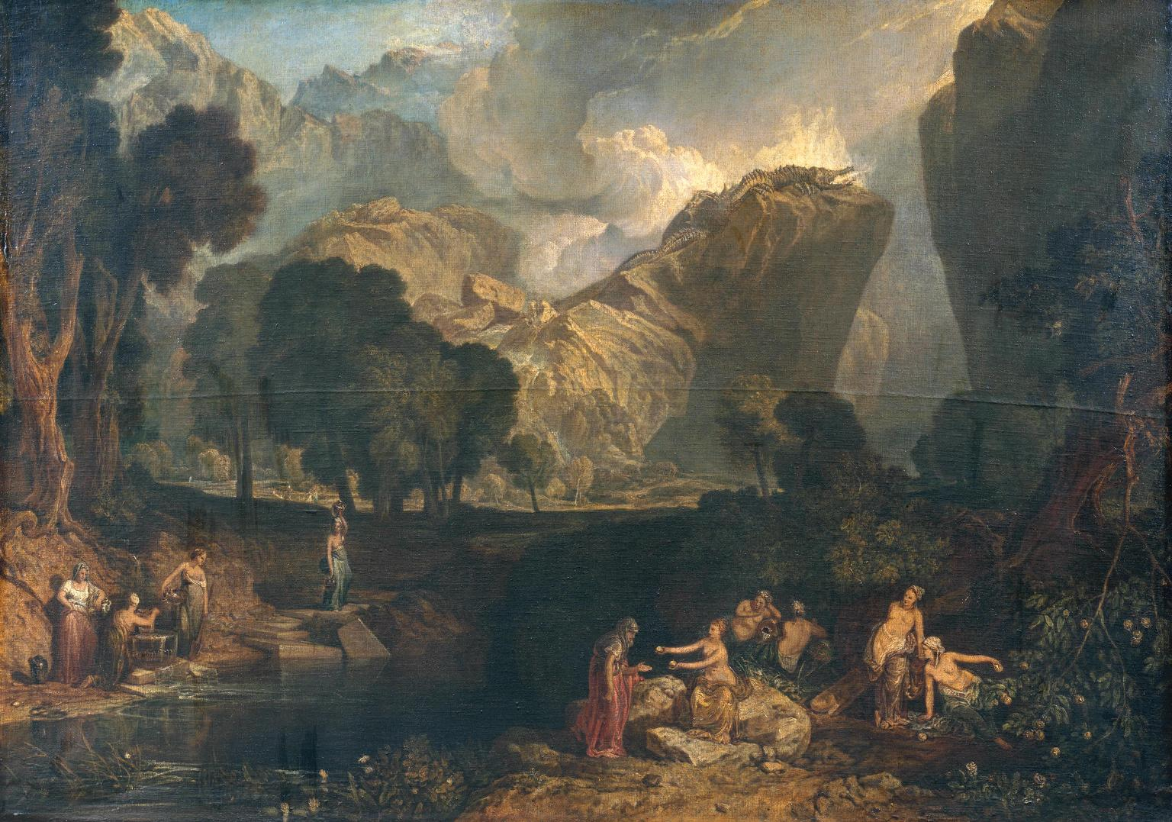

J.M.W. Turner (1775-1851), The Goddess of Discord Choosing the Apple of Contention in the Garden of the Hesperides (1806). Oil on canvas. London: Tate Britain

‘Quivi trovammo,’ says Ruskin quoting Dante: here we find him – wherever we are, there he is, at the heart of things, corrupting and poisoning the world, presiding over the triumph of what Ruskin in Unto this Last calls ‘illth’ (17.89): riches that are the source not of wealth but of its opposite. The significance of the golden apples is ambiguous. On the one hand, as watched over by the ‘bright’ Hesperides, the apples stand for the richness of nature, the wealth that is life, the fruit of fruitfulness. We are in the west, remember: the Hesperides and the apples glow in the sunset. On the other hand, as gold guarded by a dragon, they stand for the destructive power of riches, associated with greed and death and the darkness of the earth. Ruskin calls the dragon quite simply ‘the evil spirit of wealth’ (7.402). Tony Tanner in his book Venice Desired explicates the name Pluto/Plutus as follows: ‘It seems that Dante followed a medieval tradition of not distinguishing between Pluto, god of the nether regions, and Plutus, the god of riches and, more generally, wealth incarnate.’ We are in the presence of Death, and death associated with the power of money as opposed to the wealth that is life (see 17.105).
For Dante, following St Paul, ‘the love of money is the root of all evil’
and he particularly associates that evil with the practice of usury, condemned by the medieval church as mortal sin. The word ‘usury’ primarily means the lending of money at interest. Some thinkers would say it concerned excessive rates of interest; others – both Ruskin and Dante among them – the charging of interest in any circumstances and at any rate. This is severe, and to us, living under an economic system based on the charging of interest, it is extremely challenging. In Dante’s day, the widespread practice of usury was a new thing. He was appalled by it, especially as his own father was in a small way an early usurer. For Dante, money was a convenient means of exchange, but to commodify money – to have money markets and to make money out of money itself – was unnatural and blasphemous; it was tantamount to making something out of nothing – ex nihilo, as the medieval philosophers say.
This was not just a piece of theological sophistry; Dante and Ruskin agree that money is fundamentally a token representing the value of work. Usury is therefore parasitical: since you cannot make something out of nothing, the usurer is a thief, someone who steals and profits by the labour of others. But of course, Ruskin lived, as we do, under a fully developed capitalist system that had forgotten the very word ‘usury’ and its ill repute. (Usury had been legalised in England in 1572 to facilitate the growth of mercantilism.) Bernard Shaw was quite right to say, ‘Ruskin's political message to the cultured society of his day … began and ended in this simple judgement: “You are a parcel of thieves.”’
When we speak of Ruskin as the Prophet of the Anthropocene, we should focus on this juncture in his career: the transition from Modern Painters to Unto this Last in 1860, for it is here that Ruskin finally elaborates his case against modernity. We can see, as we look around us, the evil done by the dragon: the massive build-up of economic injustice, the unquestioned acceptance of state criminality, the submission of human values to the power of the machine (whether that be literal or figurative), the destruction of nature by the race appointed to be the stewards of Creation.
It used to be a commonplace of Ruskin criticism that the year 1860 marked a change of direction in his work. We can now see that the social and economic Ruskin was there from the start. There is undoubtedly a shift of focus, but we can see from this study of ‘the evil spirit of wealth’ and from the chapter naming ‘The Law of Help’ as the fundamental rule of natural order (7.203-16), that the shift comes at the climax of Modern Painters. ‘Government and co-operation,’ he there writes, ‘are in all things and eternally the Laws of Life. Anarchy and competition, eternally, and in all things, the Laws of Death’ (7.207). It is significant that much the same words are repeated as self-quotation in Unto this Last. (See 17.75.)

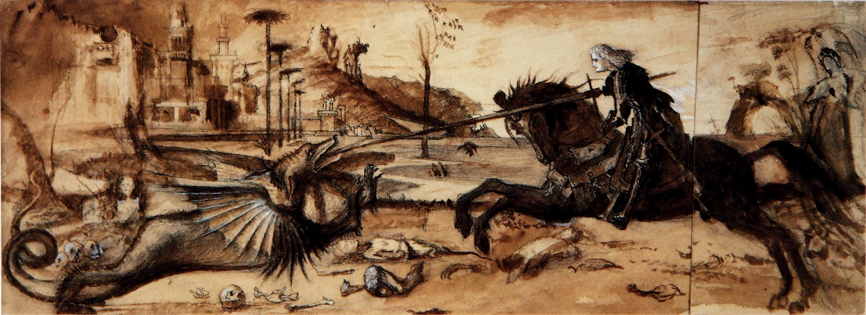

John Ruskin. Study of Carpaccio’s St George & the Dragon (c. 1870). Pencil, ink, sepia, body-colour
on two joined sheets. Guild of St George, Millennium Gallery, Sheffield

What Carpaccio added to these concerns was an antagonist to do battle with ‘the evil spirit of wealth’ and ‘the Laws of Death’. Why did it take a Venetian painter to draw Ruskin’s attention to St George, who is after all the patron saint of England? St George of Cappadocia, as he is sometimes called, was an early Christian martyr, said to have been a soldier in the Roman army; he was probably born in Palestine or somewhere else in the Near East. His cult was brought to England by the crusaders returning from the Holy Land but he remains an important saint in many different cultures, particularly in the Eastern Orthodox world. It was from the Slavic countries of the Venetian empire that his cult came to Venice, where to this day he is the patron of the district traditionally occupied by Greeks and Slavs: the Schiavoni of the Scuola’s name – St George of the Slavs. (The Scuola is also known as the Scuola Dalmata, the Dalmatian coast being one of the most important regions of the Venetian empire. It is just possible that Carpaccio may have been of Slavic origin, since he sometimes signs himself Victor Carpathius. Schiavoni, by the way, means ‘great slaves’ as well as Slavs, the two being much the same to western Europeans at that time.) Ruskin was in many ways a patriot, if a somewhat conflicted one, and the direct appeal of the name St George was to the best values of the English people, but it helped him in his sometimes scathing criticism of his country to have a saint who also belonged elsewhere – belonged in particular to the society he wanted to hold up as a model, that of medieval Venice, especially as the decline and fall of that great maritime empire was for him a constant admonition to Britain ln its imperial ascendancy.
Carpaccio’s St George is represented as the defender not only of innocence – the virginal Princess, whom later in the cycle he is to win in marriage – but of civilisation, represented by the fanciful city in the background. This city has been terrorised by the dragon, which has littered the foreground with fragments of its citizenry. Evil, in Ruskin’s understanding, brings sterility and desolation – shuts up the sources of life.

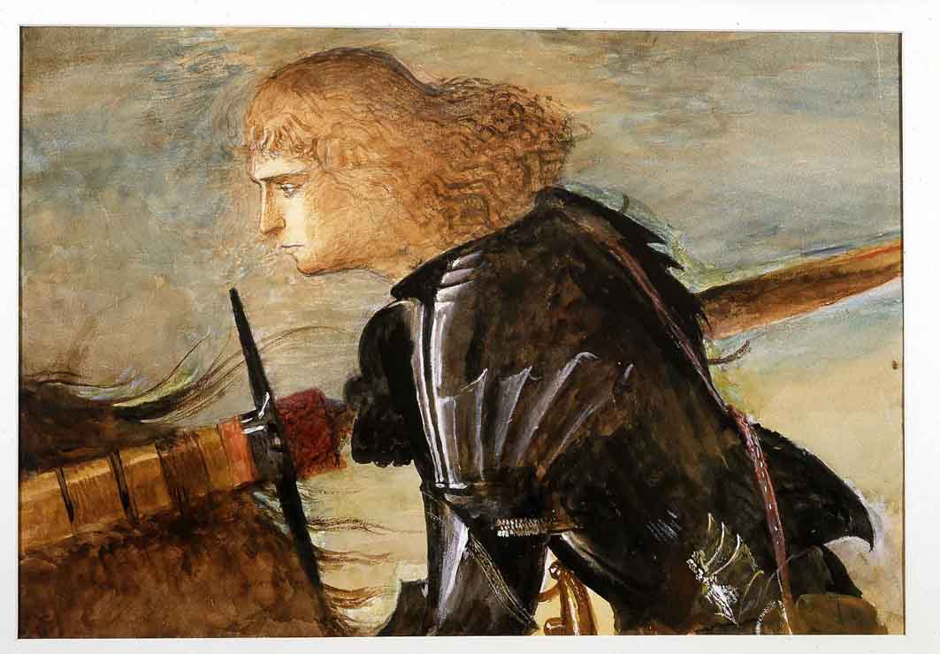

John Ruskin. Upper Part of the Figure of St George, after Carpaccio (1872). Watercolour and
body-colour on paper. Guild of St George, Millennium Gallery, Sheffield.

In Letter 26 of Fors Clavigera, dated February 1873, Ruskin outlines the characteristics of his saint: a beautiful young man who

rides armed, from shoulder to heel in proof [i.e. in armour] – but without his helmet. For the real difficulty in dragon-fights is not so much to kill your dragon as to see him… Carpaccio’s St George will have his eyes about him, and his head free to turn this way and that. (27:475. Ruskin’s italics.)

For Ruskin this is to underline the symbolism of the spiritual quest. What the knight needs more than his helmet, more even than his shield, is clear sight and its consequence, clear thinking. This is one of the ways in which a writer who began his career as an art critic developed into the particular sort of social and cultural critic that Ruskin was. To quote the famous sentence from Modern Painters III (1856): ‘To see clearly is poetry, prophecy, and religion, – all in one’ (5.333).
In 1875, Ruskin began building up an art collection for the Guild of St George in Walkley, a village on the rural edge of the great steel-making city of

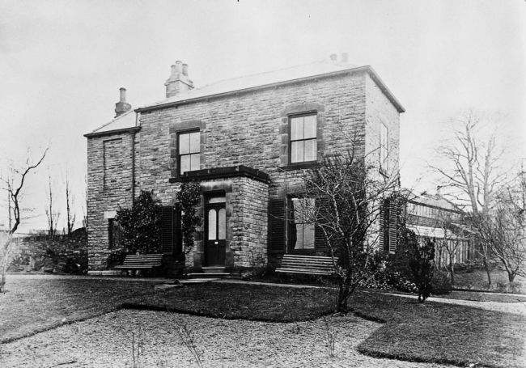

St George’s Museum, Walkley, near Sheffield, c. 1880

Sheffield. Called, St George’s Museum, the collection was designed for the enlightenment and pleasure of poor and culturally deprived artisans – for the very workmen, that is to say, who made the cutlery for which the city was famous across the world. The collection brought together a wide variety of art works, among them several copies of great masterpieces. These include two copies of Carpaccio’s St George, both of them by Ruskin; one is a drawing of the whole picture, the other a watercolour of the saint’s head. The Ruskin scholar Marcus Waithe, who has recreated St George’s Museum online as a virtual museum, suggests that the museum itself was ‘an attempt to “see” the dragon first, to take the initiative in the fight to teach better ways of witnessing the world’. At some time in the early twentieth century an image derived from the picture was adopted as the Guild’s logo – much too late for Ruskin to have chosen it. It does seem likely, however, that the name Scuola di San Giorgio played its part in Ruskin’s meditations on these matters. The word scuola is notoriously difficult to translate. It is, of course, the Italian word for ‘school’, not in the educational sense but referring to a group of people combining for a common purpose or principle: something not unlike a guild, in fact. I take it that, for Ruskin – though he never said so – Guild of St George was a loose translation of Scuola di San Giorgio.
But Ruskin was not thinking only of Venice. Very often the thought of Venice reminded him of the Alps as seen from the lagoon on a fine day. Equally often the serene Republic was balanced in Ruskin’s mind by Switzerland. He had his ‘two homes of earth,’ he said: Chamonix and Venice (35.296). Like the Swiss communities he admired so much, the Guild was to be fundamentally rural and its life focused on the given beauties of nature. What is more, Ruskin thought of its communities as having at their heart the sorts of institution in which country life is all too often deficient; schools, libraries and art galleries.
So when Ruskin, as a new decade began, surveyed his plans for it, he committed himself to two complementary campaigns. His Oxford teaching was to instruct the sons of the ruling class by opening their eyes, while his letters to the workmen and labourers of Great Britain were to deal with the state of the world, returning again and again to the injustices inflicted on the poor, and the damage done to nature by the dragon of capitalism, breathing out fire and smoke from its factory chimneys. For this, the ruin and desolation in Carpaccio’s foreground is the perfect metaphor. How, though, was St George to go into battle? Teaching was one thing, but what was to be done? And so in the first letter of Fors Clavigera, dated January 1871, we read this:

I have listened to many ingenious persons, who say we are better off now than ever we were before. I do not know how well off we were before, but I know positively that many deserving persons … have great difficulty in living in these improved circumstances… For my own part, I will put up with this state of things, passively, not an hour longer. (27.12-13)

He then proposes what he at this stage refers to as St George’s Fund.
The mordant irony of this passage continually strikes me with its uncanny relevance to the world today. Even in the alarmingly unstable circumstances of post-Brexit Britain, we British continue to boast of our country as the sixth largest economy in the world. And yet, looking around us, we see a rich country characterised in many contexts more by poverty and failure than by wealth and success – homelessness, under-funded public services, blighted post-industrial communities, over-exploited landscapes dying before our eyes, townscapes wrecked by uncontrolled or badly judged development, impoverished and soulless education, and internal division of many kinds, not least the largest gap we have known in over a century – since Ruskin’s lifetime in fact – between rich and poor. If mine is a rich country, I sometimes think, what would it be like to live a poor one?
I became the fourteenth Master of the Guild of St George, a year after the financial crash of 2008. In its publicity and publications, the modern Guild describes itself as ‘The charity for arts, crafts and the rural economy, founded by John Ruskin in 1871’. Modern charity law requires precise definitions of a charity’s objects, but the truth is that the Guild is, and always has been, as protean as Ruskin’s writings and does whatever work those writings suggest as needful and possible in a modern context. For me, as I took over leadership of the Guild, it seemed to me my first duty was to get the Guild to talk about the economy – to eyeball the dragon, so to speak – and, in alliance with the Ruskin Library and Research Centre at Lancaster University, we set up a symposium
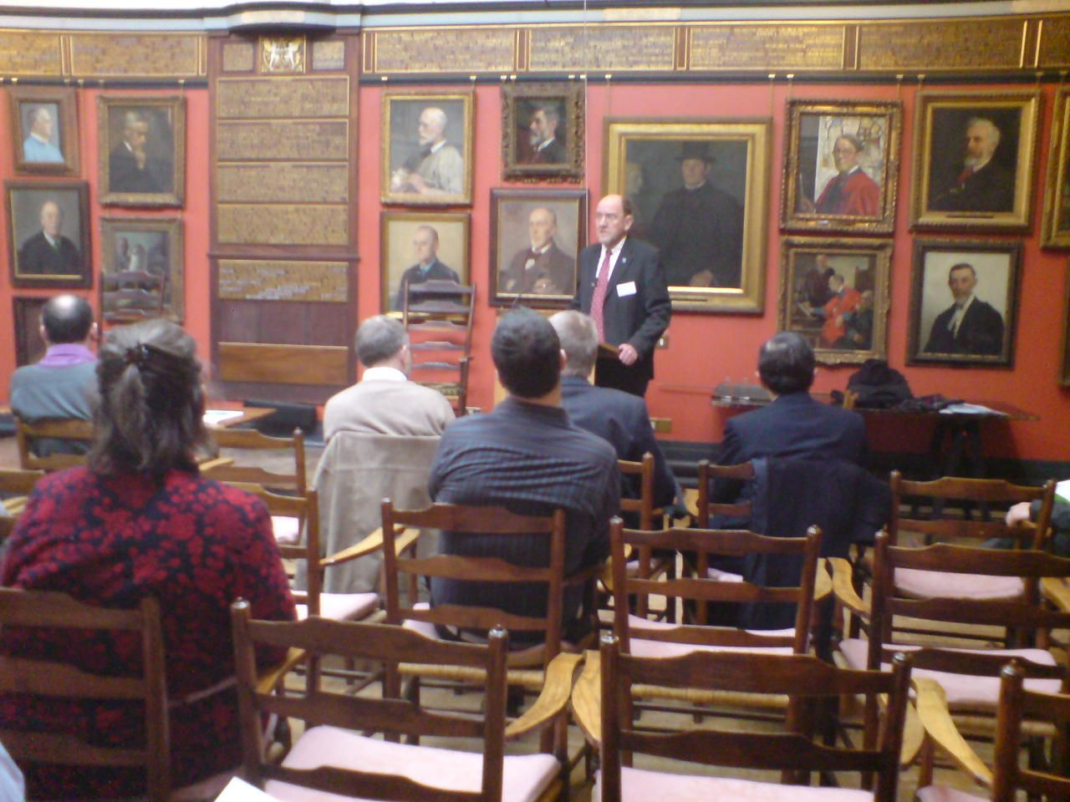
The author speaking at the symposium ‘John Ruskin and the Modern World’.
Art Workers’ Guild, 8 February 2008. (Photo: Gabriel Wilmer)

called ‘John Ruskin and the Modern World’, which was hosted by the Art Workers’ Guild in London – a setting rich with Ruskinian resonance. The
speakers were an independent-minded Labour Member of Parliament, an academic economist with an interest in the history of economic ideas, a journalist on the Financial Times and me as an editor of Ruskin’s Unto this Last. My talk, intended to focus the theme of our discussions, was called ‘Can there be an ethical economics?’
This occasion started what quickly became a Guild tradition: that at least once a year we meet in public to discuss issues of current importance in the light of Ruskin’s teaching. We have since considered the environment, education, craftsmanship, utopianism and a number of other matters. The problem in all this is the obvious one: that we are talking to ourselves – that few dissenters listen and, since we are a tiny and probably privileged minority, why should anyone listen, even if they knew there was something to listen to?
And yet… And yet though in the eyes of the world the Guild has never been a success, it has survived for150 years and the Companionship (as we call the body of members) has increased by more than 200% in the last decade. There are currently 312 Companions, just under a fifth of whom are citizens of countries other than Britain, notably the United States. Not only that, but interest in Ruskin and Ruskinian activities is increasing even faster, as
the Guild discovered when it organised an exhibition for Ruskin’s bicentenary. Between January and April of last year, the exhibition John Ruskin: The Power of Seeing attracted 57,000 viewers to the exhibition gallery Two Temple Place in London, the most successful display that institution has ever hosted, and between May and September, a similar show John Ruskin: Art and Wonder drew another 54,000 in Sheffield, where the Ruskin Collection is kept – that is, the collection originally housed in St George’s Museum. One review of the London exhibition – in the online magazine BBC Culture – was headlined ‘Was Ruskin the most important man of the last 200 years?’
So what was the Guild meant to be and to do when Ruskin launched it, and does it do anything similar today?
The Guild began as a sort of ‘back to the land’ movement, though it was never quite as simple as that suggests. Ruskin wanted to set up small, largely self-sufficient agricultural communities whose members would farm the land with care and respect for nature and live healthy lives in harmony with the physical world. He also expected there to be Companions, himself among them, who would carry on (as he put it in 1872 in Fors, Letter 17) ‘following their own business, wherever they are, but who will give the tenth of what they have, or make, for the purchase of land in England, to be cultivated by hand’ (27.296). Twelve months before that he had asked:

Will any such give the tenth of what they have, and of what they earn, – not to emigrate with, but to stay in England with; and do what is in their hands and hearts to make her a happy England? (27.95)

The object of such giving

would be to begin, and gradually – no matter how slowly – to increase the buying and securing of land in England, which shall not be built upon, but cultivated by Englishmen, with their own hands, and such help of force as they can find in wind and wave. (27.95)

And he goes on to add:

We will try to take some small piece of English ground, beautiful, peaceful, and fruitful. We will have no steam-engines upon it, and no railroads; we will have no untended or unthought-of creatures on it; none wretched, but the sick; none idle, but the dead. (27:96)

These last three quotations are all taken from just three pages of Fors, Letter 5 (May 1871). In them I have italicised a number of apparently simple expressions, which I think it will be productive to look at. But it should be said, first of all, that though the Guild of St George was intended as a practical proposition, its first purpose was as a form of criticism. Like most utopias – Sir Thomas More’s Utopia (1516), for example, which introduced the word into our language – Ruskin’s imagined society was a critique of the one he lived in and had begun to despair of. Companions are to till the land with their own hands, he says, not to be ruled by the money markets or subdued to the power of the machine. Energy is to be derived from nature – ‘wind and wave’ – not from steam engines and the like. Ruskin is thinking of the masses ‘sent’ – as he puts it in The Stones of Venice – ‘like fuel to feed the factory smoke’ (10.193) and a landscape poisoned by industrial effluent. Agricultural land will not only be economically productive but will give peace to the soul, as the God of Modern Painters intended: that is to say, it will be beautiful and peaceful, but also fruitful – for Ruskin, I suspect, a biblical word but one that implies economic gain. God will give us the land to steward and we will support ourselves on the proceeds. There is no sense here of the land simply offering up its gifts to the idle.
So the critique leads us on to a picture of how we might live, and the ultimate hope is that this dreamed-of England, so different from the familiar one, will be ‘a happy England’. ‘Happy’ looks like the simplest of all these words, but it is a word that Ruskin used much more frequently than most of us notice. Perhaps he had in mind an antagonist, the Utilitarian philosopher Jeremy Bentham, who wrote that ‘the greatest happiness of the greatest number … is the measure of right and wrong’. Ruskin says something to compare and contrast with Bentham in a famous passage from Unto this Last:

THERE IS NO WEALTH BUT LIFE. ... That country is the richest which nourishes the greatest number of noble and happy human beings… (17.105)

‘Happy human beings.’ I do not think Ruskin is saying anything difficult here. It is a truism that love and happiness cannot be bought. But it is always useful with Ruskin to look at the sources of words, their ancient meanings and their etymologies. ‘Fors clavigera’ means, among other things, Fortune ‘the nail-bearer’ (27.28), and ‘happiness’ (as Ruskin was aware) derives from the old English word ‘hap’, which also means fortune. A happy person is one who has been able to nail down the good fortune that life offers, for it is an assumption of Ruskin’s teaching that the world includes the conditions of paradise, did we allow ourselves to see them and grasp them.
If we say that the Guild was not a success, what do we mean exactly? To begin with, Ruskin was not a natural administrator. To give one simple example of that, there is no single and reliable record of the Companionship during his nearly thirty years as as Master. The closest to such a thing we have is a list of thirty-one names written on the flyleaf of an illuminated Bible! And the list does not include the names of several people known to have been Companions. To make matters worse, Ruskin’s mental health began to fail in the course of the 1870s, and in 1878 – the year in which, after seven years, he finally managed to agree the name Guild of St George with Companies House – he suffered the first of seven mental breakdowns. It is noteworthy that several of his closest followers never signed up, no doubt because in some cases they feared his instability and its possible consequences.
At the same time, when Ruskin was struck by a compelling project, he poured funds and passion into it. St George’s Museum in Sheffield, started in 1875, is the prime example. There is no museum in the world like it and the substance of it has survived many vicissitudes. In the mid-twentieth century, Ruskin’s reputation went into what looked like terminal decline and in 1951 the Collection lost the support of the Sheffield authorities with the result that for about thirty years it was kept in storage in the art department of Reading University. Yet in the early 1980s it was brought back to Sheffield and is now kept and selectively displayed in the city’s Millennium Gallery, built in 1999.

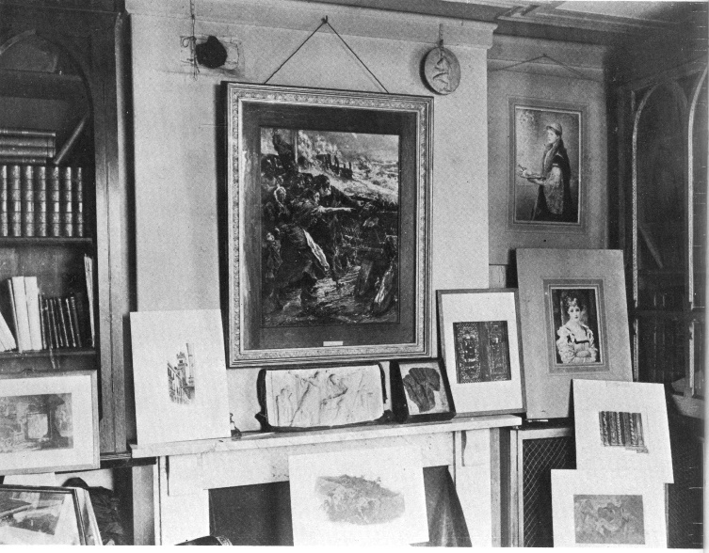
St George’s Museum, Walkley, near Sheffield. The interior in the 1880s.

Those who work for the Guild have long been conscious that the Collection is dear to the hearts of Sheffield people, many of whom have some sense that Ruskin gave it to their forebears at his own expense at a time when the conditions of life for the metalworkers were as dire as can be imagined. Frequently moved by expressions of loyalty and gratitude towards Ruskin, often from people without the education to make much of his writings, I began to think about ways of deepening the Guild’s link with the city and in 2015 we launched a five-year project called ‘Ruskin in Sheffield’. Taking over as Master in 2009, I had begun to feel a problem in the Guild’s position. We had inherited important properties from Ruskin’s day, but those properties had lost much of their function. The Collection was not unappreciated, but Ruskin had created it to change people’s lives. With the Collection now located in the city centre, it had become our responsibility to reach out into the communities outside that centre. Under the leadership of an inspired communicator and enthusiast named Ruth Nutter, ‘Ruskin in Sheffield’ has attracted some 25,000, adults and children, to engage in revitalising their communities through the appreciation and practice of art. As a result, since the project started, the Guild has acquired some fifty new Companions from the ordinary Sheffield population. It has been a way of nailing down good fortune.

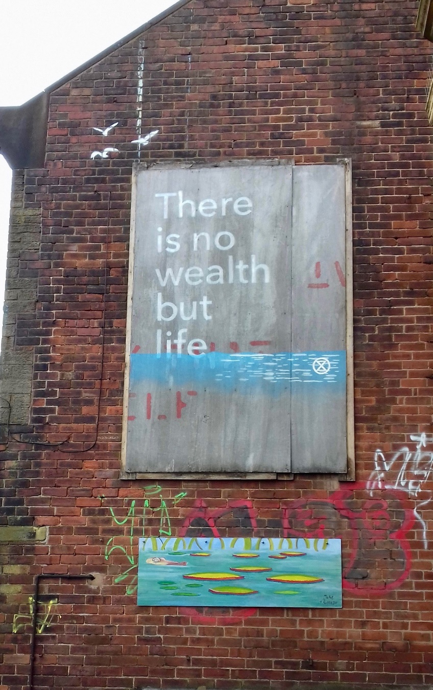

John Ruskin’s maxim ’There is no wealth but life’ appeared on this
billboard in Walkley in July 2019, apparently signed by Extinction Rebellion,
the environmentalist pressure group. It appears above a mural created by a
teenager as part of a Ruskin in Sheffield project. (Photo: Ruth Nutter.)

When I speak of the Sheffield project, I often use the expression ‘digging deeper in’. It seems to me that this is what the Guild has done, both now and in Ruskin’s day. Properties have come to the Guild piecemeal and unpredictably. There was and is no grand plan. The point is to deepen the value and meaning of what you have, which is particular and local. Apart from the Sheffield Collection, the most important property the Guild has inherited from Ruskin’s time is Ruskin Land in the Wyre Forest, which is near the pretty town of Bewdley in Worcestershire, not far from the Welsh border on the English side. The Wyre Forest is the second largest ancient forest in England with an area of 6059 acres. It consists predominantly of massively impressive oak trees and is host to a wide range of wildlife. A remarkable entrepreneur and public benefactor, George Baker, who was Mayor of Britain’s second city

Fallow deer in the Wyre Forest. (Photo: John Iles)

Birmingham and owned a grand house in the Wyre, responded immediately to Ruskin’s first plea for donations of land in 1871. He gave the Guild seven acres of woodland, and six years later increased his gift to twenty. In Letter 80 of Fors, Ruskin evokes ‘a sweet space of English hill, dale and orchard, yet unhurt by the hand of man’ (29.171), which is a good description. The Guild’s land, which has since expanded to 155 acres, comprises two small farms, a number of orchards and a great deal of imposing forest. It has come to be known as Ruskin Land. The Guild Director responsible for the Wyre, John Iles, lives in one of the farms and has worked to transform the place, which had come to be regarded in the post-war period as uneconomic. Working through a local co-operative, the Wyre Community Land Trust, a recipient of Guild funding, he has caused orchards to be replanted and restored, sometimes reviving the lay-out of Ruskin’s era; they have turned monocultural fields into heart-breakingly lovely wildflower meadows; they have begun thinning the forest to encourage thicker growth in the trees. The land is managed according to the highest standards of sustainability and biodiversity, which is an excellent example of the way Ruskin’s teaching easily mutates into contemporary, even cutting-edge, practices, What is more, here, as in Sheffield, numbers of local people have become involved in the Guild and its other work.
The example of Sheffield led in time to a two-year project named ‘Ruskin in Wyre’, which explored the complex history and culture of the forest and, at the same time, looked at ways in which it could develop today, for instance in providing opportunities for local handicraft. The forest was the one place in the Guild’s hundred-and-fifty-year history where something like a utopian community developed. In 1908 a young family in Liverpool decided to take up the tenancy of one of the Guild farms, then newly built, and try to live the sort of life recommended by Ruskin. They were followed by other families from Liverpool and built what seems to have been a successful community. Remarkably, one of the couples started a family as late as the 1930s, and one of

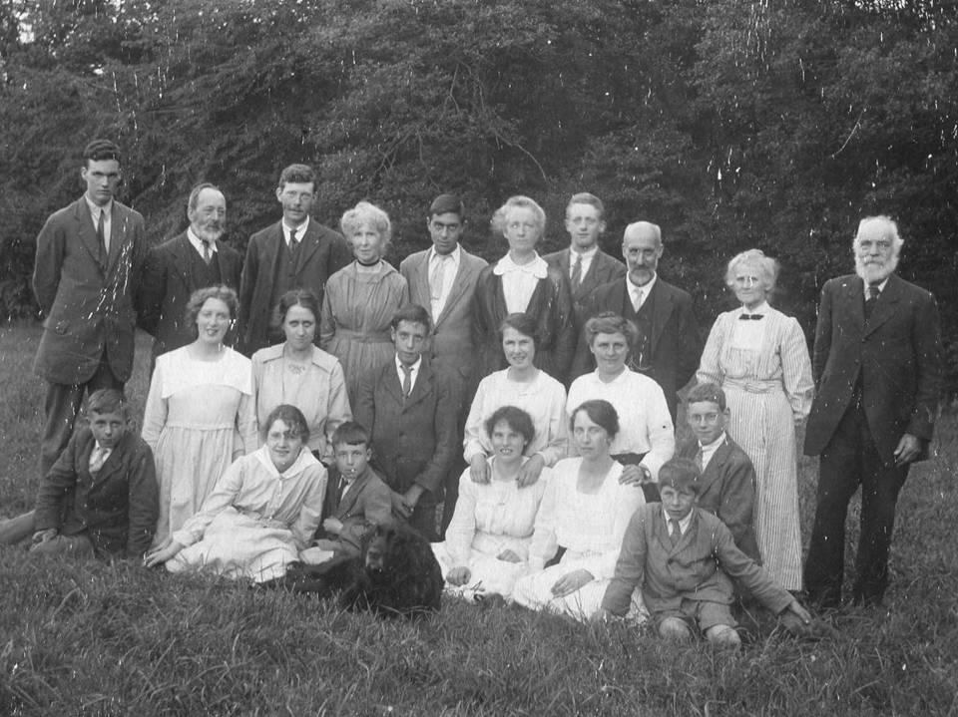

A picnic in the Wyre Forest, c. 1915/16. Cedric Quayle, who owns this photo, calls it: ‘An Arcadian scene in the midst of that terrible war.’ These are some of the families that came from Liverpool to settle in Ruskin Land. Cedric Quayle’s father is the boy sitting next to the dog; in the back row are (second, third and fourth from the left) his grandfather, uncle and grandmother. His grandfather had joined the Guild in 1885.

their sons, Cedric Quayle, went on to become the Guild’s Secretary, holding that office with distinction from 1992 to 2006. He is also co-author of a valuable history of the Guild’s relationship with the region. Cedric, I am glad to say, is still with us, a valuable link with the era of Ruskin’s influence and the inspiration behind a living community in Ruskin Land, actively connected with the world outside the forest. Cedric recently told me that in 1969, when he joined the Guild at an Annual General Meeting, there were only nine Companions present. At the AGM in 2019 there were eighty-five.
So the Guild survives in its fragmentary way and Companions work to enrich and deepen the fragments, so that they become something more substantial than that word suggests. The work they do is in the strict sense exemplary: it provides examples of how life can be lived, is lived in these cases and might be lived elsewhere. The Guild is very keen on particularity and on physical work – art, handicraft, husbandry of field, orchard and woodland – but the particulars may be exemplary, with implications for the larger world. It is in this sense that, small as their number is, Companions go into battle, day by day, helmets off, to fight against the forces of greed and destruction.

Quoted in E.T. Cook, The Life of John Ruskin, 2 vols (London: George Allen, 1911), 2: 165
Ibid., 2: 166
John Ruskin: The Later Years (New Haven and London: Yale University Press, 2000), 188
Published as Lectures on Art (1870) and Aratra Pentelici (1872)
For Ruskin’s explanation of the title, see 27. 27-29.
I am indebted to Marcus Waithe for one source of this very Victorian phrase. It occurs in the catalogue to the 1865 exhibition of paintings by Ford Madox Brown, which included his best-known picture, Work. Brown contrasts the navvies in the foreground of the painting with the by-standing figures of Thomas Carlyle and F.D. Maurice, ‘the brain-workers who, seeming to be idle, work, and are the cause of well-ordained work and happiness in others’ (The Exhibition of "Work", and Other Paintings, by Ford Madox Brown, 191 Piccadilly (London: McCorquodale, 1865), 28).
Dante, Inferno, 6.66-67
Tony Tanner, Venice Desired (Oxford: Blackwell, 1992, p. 135. For all that I say about The Garden of the Hesperides, I am indebted to Tanner. It was indeed Tanner who first urged me to read Ruskin when he taught me at Cambridge in the 1960s.
I Timothy 6: 10
Bernard Shaw, Ruskin’s Politics (London: The Ruskin Centenary Council, 1921), p. 11.
Ruskin at Walkley: https://www.ruskinatwalkley.org/
Waithe, ‘Upper part of the figure of St George, after Carpaccio’, ibid. – https://www.ruskinatwalkley.org/object.php?hotspots=off&room=6&object=100
The earliest dated example of the logo that colleagues more learned than I have been able to uncover is the heading for the Guild’s Annual Report of 1933. It is in the collection of James Dearden, my predecessor as Master.
The other countries represented in the Companionship are: Australia, Canada, France, India, Italy, Japan, Jordan, Norway and Portugal.
https://www.bbc.com/culture/article/20190207-was-ruskin-the-most-important-man-of-the-last-200-years
https://en.wikipedia.org/wiki/Jeremy_Bentham
For a record of the Ruskin in Sheffield project, see Ruth Nutter, Paradise is Here: Building Community Around Things that Matter (Sheffield: Guild of St George, 2020).
Peter Wardle and Cedric Quayle, Ruskin and Bewdley, revised edition (Bembridge, Isle of Wight: Guild of St George, 2007)

