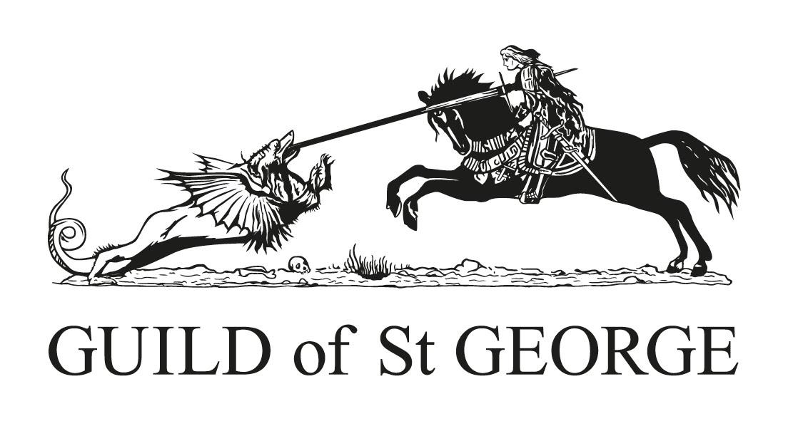 | From the Master,  Dr Rachel Dickinson  1 Rectory Barn, Foundry Lane, Halton, LANCS, LA2 6LT, UK  master@guildofstgeorge.org.uk  22nd October 2021

Dear Companion,

I am writing to invite you to meet with me and fellow Companions at the Guild of St George’s annual gathering and AGM. I do so in the knowledge that in recent weeks we have lost two distinguished Companions, Jim Dearden and Patrick Harding, a sad moment for us all.
This year marks the 150th anniversary of the founding of the Guild, established by Ruskin as St George’s Company in 1871, and so we will be thinking about the past, but we will also very much be focused on our future. What might have seemed speculative science-fiction – to hold our annual gathering online – will in fact take place this way for the second time this year, on Saturday the 20th November from 2-5.30. Because of the uncertainties brought by COVID-19, our Board made the decision several months ago to hold this meeting on Zoom, at this link: https://us02web.zoom.us/j/83574773003. In our aim to be good stewards of the Guild’s economic resources and of global environmental resources, we are continuing the pattern set last year of only posting paper copies of the documents to the few Companions who do not use email. Can you please let our administrator, Martin Green, know if you plan to attend the AGM part of our meeting (from 2-3.45pm) or require a proxy? This can be done by email at admin@guildofstgeorge.org.uk. For further details, please refer to the Introduction to the accompanying AGM booklet. As part of the event, I am delighted that Companion Stuart Eagles will be talking to us about the fascinating subject of his new Guild booklet, the 3rd Master of the Guild, Ruskinian industrialist George Thomson, and we will also hear from two of the recipients of our 2020 Companion Grants, Anna Netri and Sarah Woods, about their grant-related activity.
While we will miss being able to catch up in person, this arrangement does bring the significant benefit of enabling us more easily to meet as a global body. We have chosen a time which should work for as many people as possible: the Zoom room will open at 1.45 ahead of a punctual 2pm start, so please join the meeting before 2. We aim to end the formal AGM at 3.45, followed by presentations and discussions to end at 5.30. Those UK times translate into a 10 pm start for our Japanese Companions and an end time of 9.30 am for our Californian Companions; our hope is that as many of our number as possible will be able to attend, even if not for the full three and a half hours.
At this AGM, we will welcome the 12 new Companions who have been accepted this year, and look forward to a future AGM when these Companions, last year’s new Companions, and all who have not yet signed the roll will be able to do so. We will welcome some new Directors to the Board, and say farewell to those who have retired in the last year. We are delighted that four individuals have responded to appeals to fill gaps on the Board: Mark Cleaver and Mark Frost have been appointed as Trustees, the former with the portfolio for Land Management & Environmental Matters and the latter for Ruskin Studies & Legacies; Arjun Jain has become the inaugural Young Companions’ Representative to the Board; and, Jenny Robbins has added the role of Treasurer to her existing portfolio of Properties. You will hear each of them, as well as the other Directors – Peter Burman (Craftspeople and Craftsmanship & International Relations), Nichola Johnson (Collections & Exhibitions), Peter Miller (Publications) and me as Master – report on our areas. You will also be able to join the board in thanking Directors who have retired since the last AGM – Carolyn Butterworth, Howard Hull and John Iles – as well as Louise Pullen, who has chosen to step down as the Curator of the Ruskin Collection and leave Sheffield Museums Trust.

The pandemic has brought significant change and opened a space for all of us to rethink how things have been done in the past. Two questions the Board has been asking are: what is distinctive about the Guild of St George, and what does it mean to be a Companion? At this AGM, we want to start a wider discussion of this with Companions, mapping a future for ourselves with an eye to 2028 (the 150th Anniversary of the incorporation of the Guild) and a path through the next 150 years. I will therefore be sharing my thoughts towards the end of our annual gathering and the breakout rooms that follow are designed to get that conversation among you started, and provide an informal space to meet and chat with each other.
Such on-line conversations between Companions have been a highlight of my year. It has been a joy to hear the important things which matter to us collectively and how we are endeavouring as individuals to put ‘no wealth but life’ into practice. We have considered topics including asylum seekers, pollution, and technology, and have read and discussed extracts from Fors Clavigera chosen because they set out aspects of Ruskin’s vision for the Guild. Looking ahead, we are launching a new monthly reading series on Fridays (at 5.30pm UK time) between December and March 2022. Conceived of by Peter Burman and past-Master Clive Wilmer, these will focus on Ruskin’s beloved Venice and culminate in an on-line conference on April 2nd.
While unique, Venice reflects global issues. That idea of interconnectedness informs our increasing commitment to work in partnership with other bodies, including long-term partners Sheffield Museums Trust (caretaker of our collection) and the Wyre Community Land Trust (our agents in Ruskin Land). Both have undergone significant change this year, which you will hear about at the AGM. We are planning continued activity with the Big Draw (home of the Ruskin Prize), and are in conversation with other groups whose histories are akin to our own, such as the Art Workers’ Guild. Ruskin wrote the Guild’s original creed so that people of all faiths could sign it. Yet, we are conscious that the Guild is not as diverse in membership or governance as it might be. So, as promised at last year’s AGM, this year the board has taken part in diversity and inclusion training to help us consciously consider ways to make the Guild as welcoming to all as we can. We are strengthening our stance in relation to environmental issues: Companion Anna Netri is our representative on the South Yorkshire Climate Alliance; we are a founding signatory of the ‘COP26 Declaration: asset owner climate expectations of asset management’; and, we are working closely with our asset managers to ensure Guild funds are invested in the most ethical way possible.
As a Guild, we are fortunate that past generations of Companions starting with Ruskin himself have given gifts that now form our tangible assets: the Ruskin Collection; Ruskin Land, including three houses, forest and agricultural land in the Wyre Valley; houses in the Hertfordshire village of Westmill; and a precious wildflower meadow in Sheepscombe. However, while our intangible assets – all of us as Companions – have grown and added to the richness of the Guild in recent years, our tangible assets have not. Currently, only 12% of Companions give regular financial support to the Guild. Even in significantly scaling back our activity post-2019 as we promised to do, the Guild is still spending significantly more than it brings in. Yet, we have a collective vision to make a positive impact. We seriously are considering how to secure a future for the Guild without having to sell another property or treasure from the collection, which have been the solutions in the past. We will be talking about the balance of finances and vision at the AGM. It has been a difficult time for many, and we appreciate all that you are able to offer in support to the Guild. If you can make a contribution, please refer to the guidance in the invitation to the AGM and the attached donation documents.
Finally, I would like to give you a head's up about two matters for 2022. Early in the new year, we plan to issue a simple digital magazine, containing many of the articles and reviews that have been contributed to our e-newsletters in the last 12 months. We will also be inviting Companions with something on their minds they'd like to share, to submit a 500 word reflection on the year to include in this e-magazine. Simon Seligman will be in touch later this year with details. Looking ahead to spring, I hope to see as many of you as possible at an in-person event we have begun to plan in Ruskin Land for the St George’s Day weekend, April 23rd, 2022.

Looking forward to seeing you at this virtual AGM.

